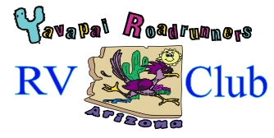

WHO WE ARE:
… owners of various types of RV’s: trailers, fifth wheels, Class A’s, Class C’s, etc. We have a great time attending organized campouts and rallies.

Organized in 1997 with 7 couples, we have grown to approximately 60 members. New members and visitors are welcome.

Quarterly meetings are held beginning with a delicious potluck dinner, a short business meeting, and an opportunity to visit with our friends.

Community topics that could affect our group, a review of places visited, schedule, and opportunities to sign up for future trips are standard subjects covered.

- Dues are $50 per year per rig. These fees are used primarily for sponsored event reimbursements.
- Name Badges are $5 each (one-time fee)..

MAJOR BENEFITS:
- Sharing experiences/locations.
- Unit maintenance/solutions.
- Campouts, coordinate with other groups, rallies, etc.
- Unit discussions, upgrade recommendations and benefits.
- Menu ideas, cooking, and equipment.
- Make new friends.

Whether new to RV life or an experienced RVer, you will have an opportunity to visit remote parks and beautiful areas of the Southwest in the company of friendly club members.

Attendance at our quarterly meetings is a good place to learn about RVing and use the experience of other members.
TYPICAL OUTINGS:
Arizona
Casa Grande
Cottonwood: Dead Horse Ranch State Park
Grand Canyon: North & South Rims
Holbrook
Parker: Buckskin Mountain State Park
Quartzsite
Show Low: Fool Hollow Lake State Park
Tombstone
Tucson: Catalina State Park
White Mountains
Williams
Yuma

Other States
Durango, Colorado
Branson, Missouri
Laughlin, Nevada
Las Cruces, New Mexico
Moab, Utah

SOCIAL ACTIVITIES:
Quarterly Meetings
Outings
Happy Hours
Potlucks
Games & Tournaments
Crafts
Training/Maintenance Help
Annual Christmas Dinner

We are Sponsored by:
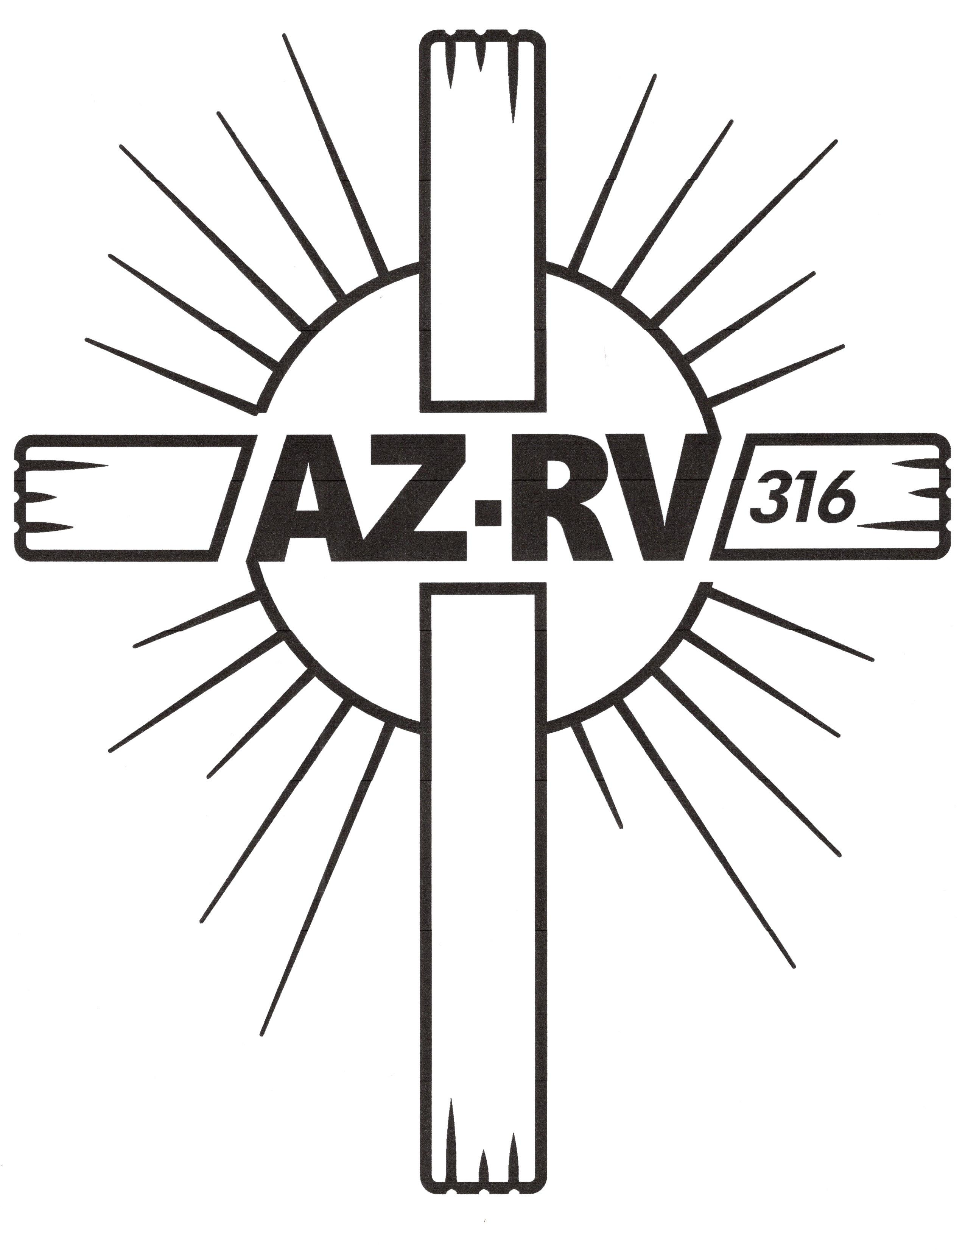

Roadrunners RV Club Membership Application
(includes mailings, quarterly meetings, roster, schedule of camp outs, etc.)

Date: ______________________________________

Name(s):_______________________________________________________________________________________
Address: _________________________________________ City: _______________ ST: _____ Zip: __________
RV Type:______________________________________ Length: _______________ # Slide outs: _____________

Dues: $50.00 per year per rig

Name Badges: $5.00 each (one-time fee) (please print name as you want it to appear on your badge)

Badge 1 Name:_________________________________________________________________________________
Badge 1 home phone __________________________ Badge 1 cell phone _______________________________
Badge 1 e-mail __________________________________________________

Badge 2 Name:_________________________________________________________________________________
Badge 2 home phone __________________________ Badge 2 cell phone _______________________________
(optional) (optional)
Badge 2 e-mail __________________________________________________
(optional)

Make check(s) payable to: Yavapai Roadrunners RV Club

Mail to: Sally Rosenfeld —2820 N. Sioux Dr., Chino Valley, 86323
For Information: (661) 212-4787 or e-mail: rosenfeldsally@gmail.com

Revised November, 2025

